**Assignment no 1**

**CONSTRAINT**

**Q1.** Create a table students with columns: id (INT), name (VARCHAR, NOT NULL), and age (INT with default 18).

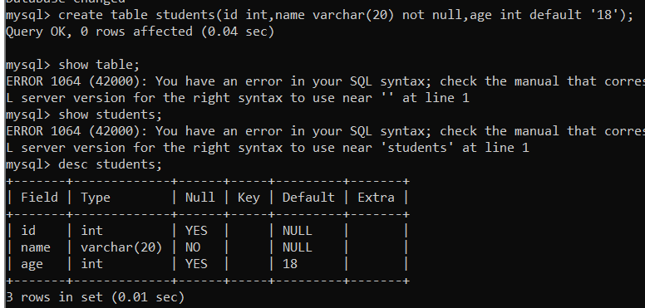

**Q2.** Insert into students: (1, NULL, 20). What will happen?

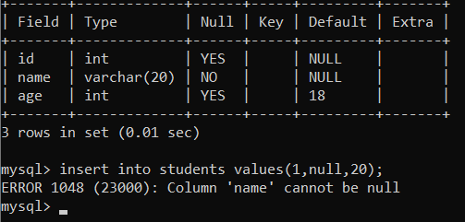

**Q3.** Insert into students: (2, 'Ravi'). What will be stored in age?



**Q4.** Why will the following query fail?

INSERT INTO students (id) VALUES (3);

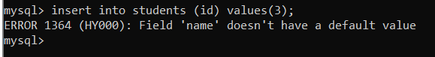

**Q5.** Modify the students table so that the age column default changes from 18 to 21.

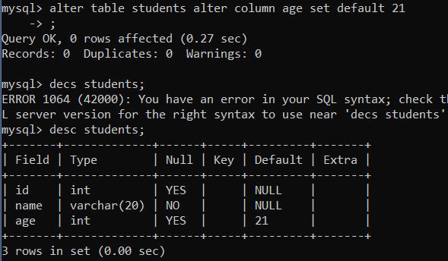

**Q6.** Drop the NOT NULL constraint on the name column. Write the query.

**Q7.** Create a table department with columns: dept_id (INT, PRIMARY KEY), dept_name (VARCHAR).

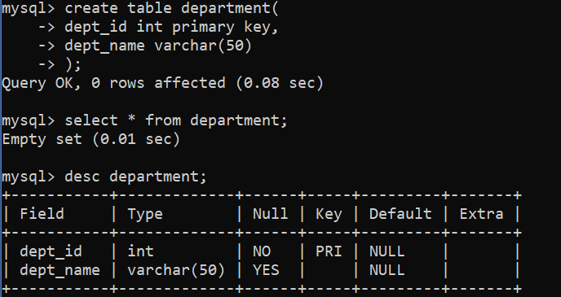

**Q8.** Insert (1,'IT') and (1,'HR'). What error will you get?



**Q9.** Can a table have two PRIMARY KEYS? Demonstrate with a query.

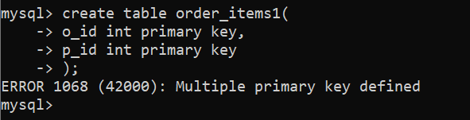

**Q10.** Create a table enrollment with composite primary key (student_id, course_id).

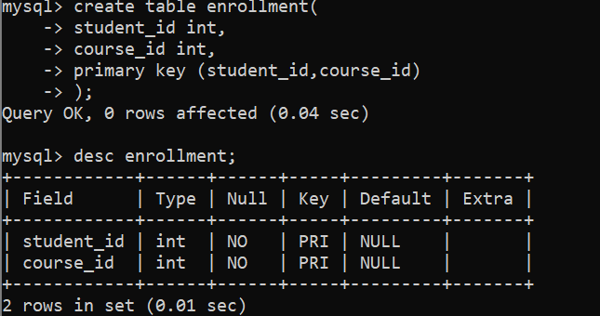

**Q11.** Try inserting (101, 'DBMS') twice into enrollment. What happens?



**Q12.** Create a table users with columns: user_id (INT, PRIMARY KEY, AUTO_INCREMENT), email (VARCHAR, UNIQUE).

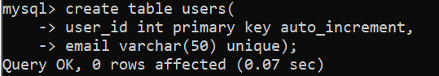

**Q13.** Insert ('abc@mail.com') twice. What error occurs?

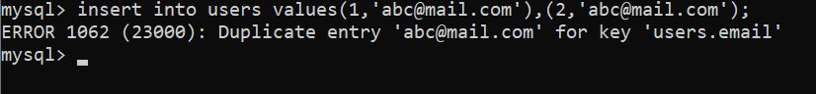

**Q14.** Does the following query work? Why?

INSERT INTO users (email) VALUES (NULL);

INSERT INTO users (email) VALUES (NULL);

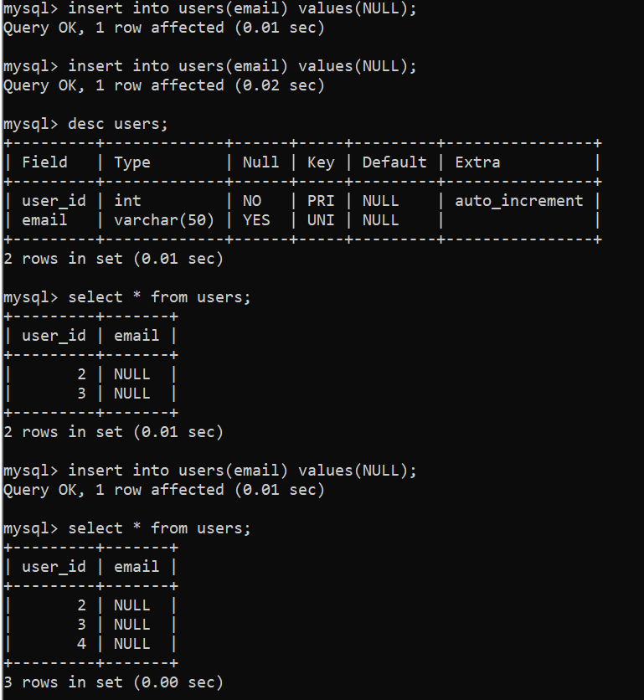

**Q15.** Create a table products with UNIQUE constraint on (sku, region).

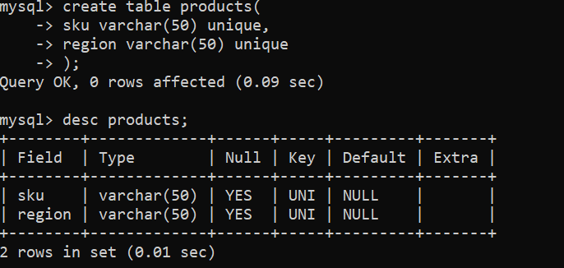

**Q16.** Insert (sku='A1', region='US') twice. What error?

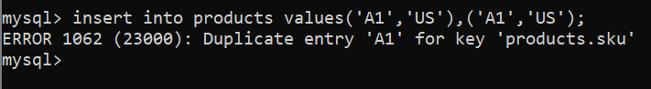

**Q17.** Create a table department with primary key dept_id. Then create employee table with foreign key dept_id referencing department.

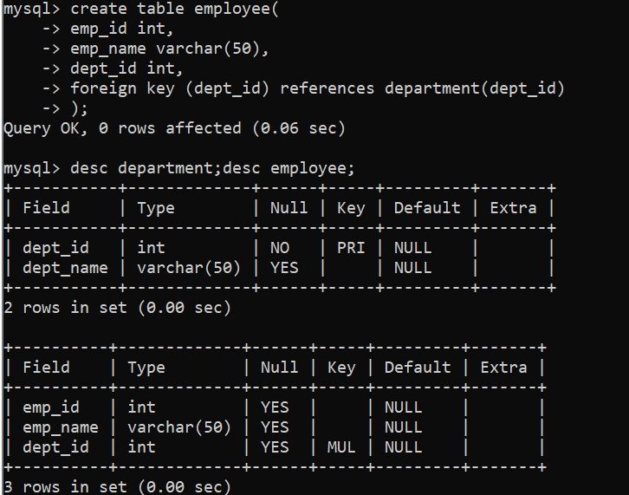

**Q18.** Insert into employee (emp_id=1, name='Asha', dept_id=99) when no such dept exists. What error?

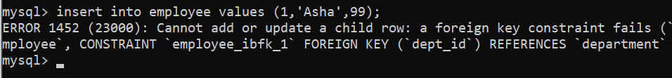

**Q19.** Delete dept_id=1 from department when employees exist. What error without ON DELETE CASCADE?

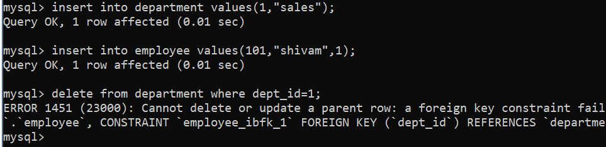

**Q20.** Recreate employee table with ON DELETE CASCADE. What happens if you delete department 1?

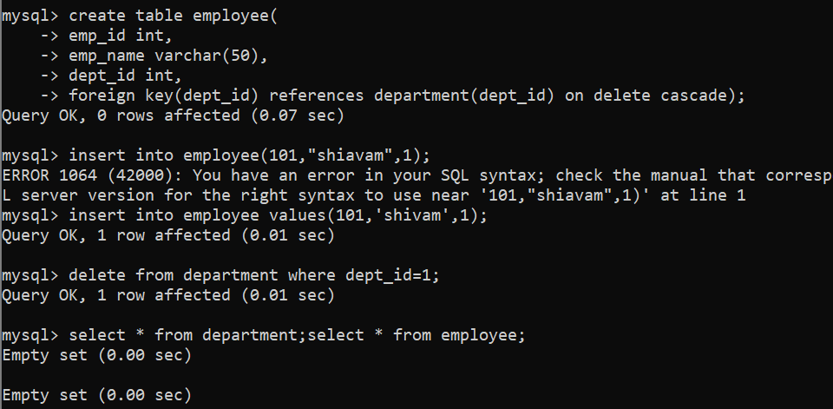

**Q21.** Use ON DELETE SET NULL in the foreign key. What happens when parent is deleted?

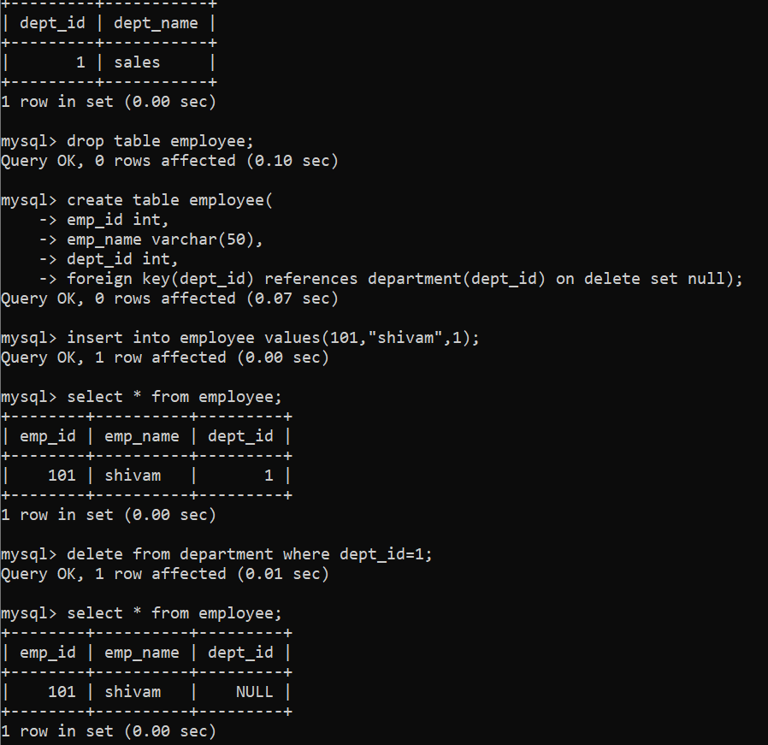

**Q22.** Write a query to drop a foreign key constraint fk_emp_dept.



**Q23.** Add a new foreign key constraint fk_manager in employee table referencing itself (manager_id).

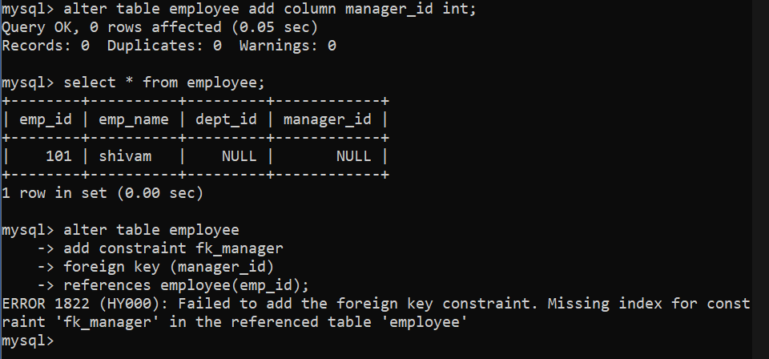

**Q24.** Create table accounts with balance >= 0 using CHECK.

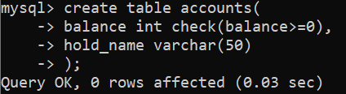

**Q25.** Insert (id=1, balance=-100). What happens?



**Q26.** Modify the constraint so that balance must be between 100 and 1,000,000.

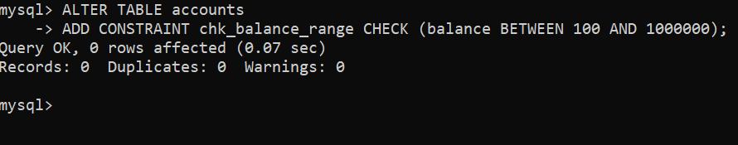

**Q27.** Try to insert (id=2, balance=50). What error do you get?

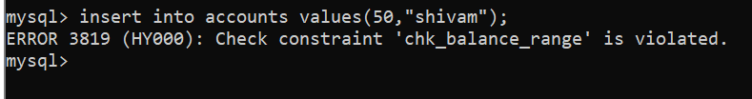

**Q28.** Create table invoices with invoice_id AUTO_INCREMENT PRIMARY KEY. Insert 3 rows. What will be the IDs?

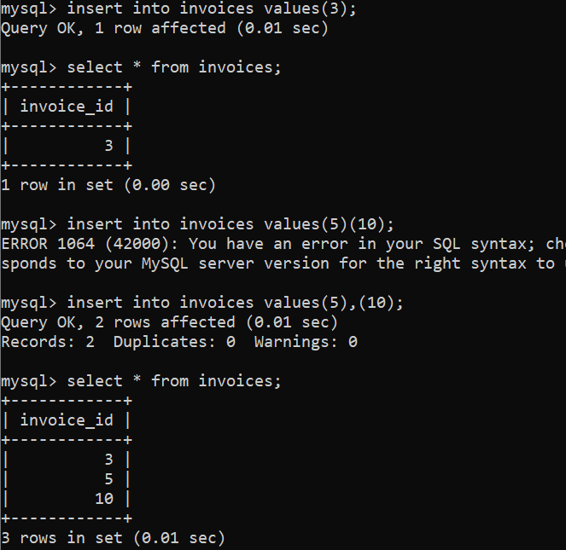

**Q29.** Delete last row. Insert again. Will AUTO_INCREMENT reuse the deleted number?

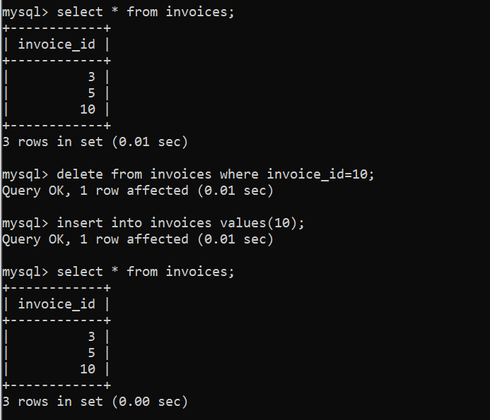

**Q30.** Write queries to:

1. Add a UNIQUE constraint on phone column in users.

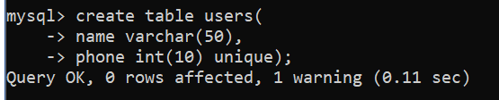

1. Drop the UNIQUE constraint from users.

**Q31.** Create a table library with a composite primary key (book_id, branch_id) and a UNIQUE constraint on (isbn, branch_id).

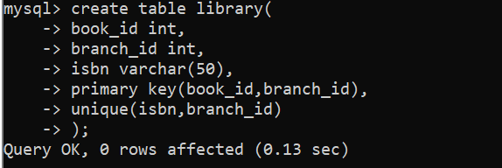

**Q32.** Insert (book_id=1, branch_id=101, isbn='A123') twice. What error occurs?

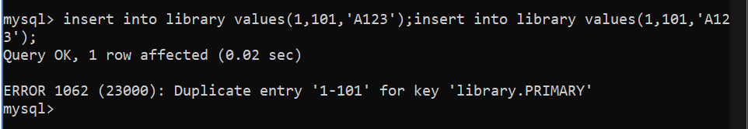

**Q33.** Insert (book_id=1, branch_id=102, isbn='A123'). Will it work? Why?

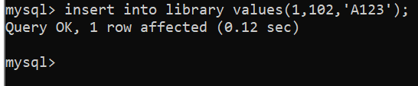

**Q34.** Can you have a table with **PRIMARY KEY** and **multiple UNIQUE constraints**? Write a query.

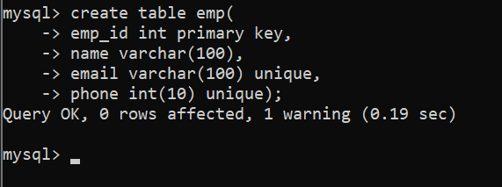

**Q35.** Try to create a table with both PRIMARY KEY(id) and UNIQUE(id). What happens?

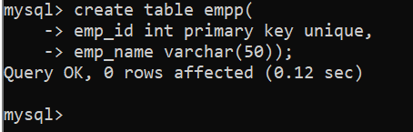

**Q36.** Create table exam_results with composite primary key (student_id, exam_id) and CHECK constraint marks BETWEEN 0 AND 100.

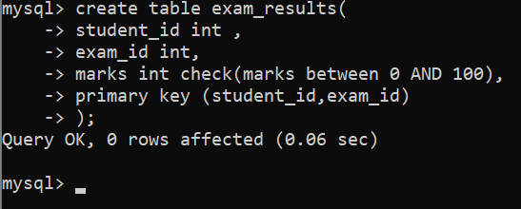

**Q37.** Create table orders referencing customers with ON UPDATE CASCADE. Update customer_id in parent – what happens in child?

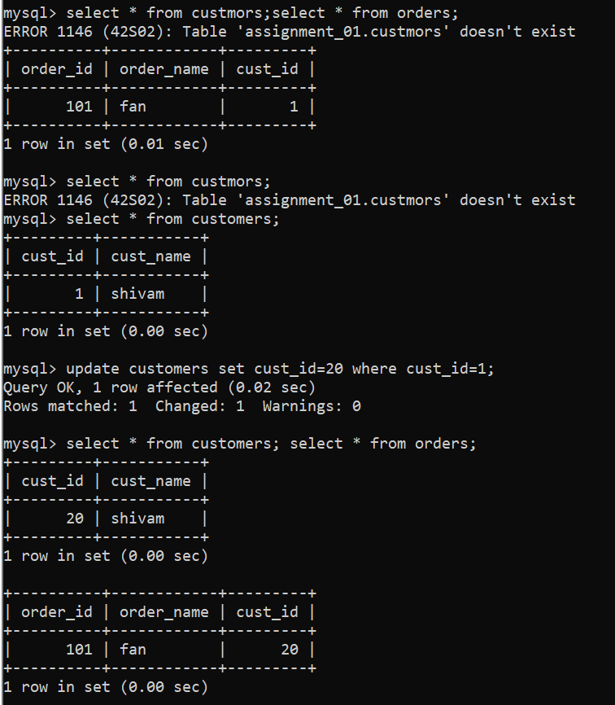

**Q38.** Try to use ON DELETE SET DEFAULT in a foreign key. What happens in MySQL?

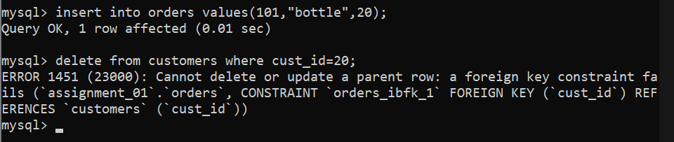

**Q39.** Create a self-referencing foreign key categories(parent_id) referencing categories(id). Insert parent and child categories.

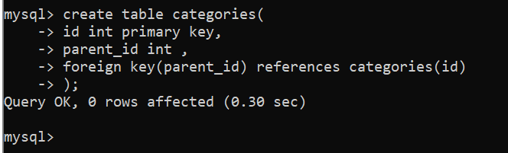

**Q40.** What happens if you delete a parent row in categories without ON DELETE CASCADE?

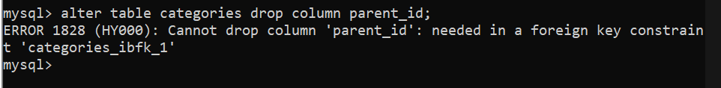

**Q41.** Write a query to temporarily disable foreign key checks and insert invalid data.

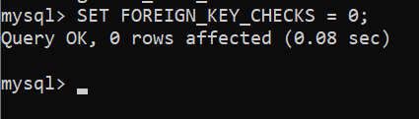

**Q42.** Write a query to re-enable foreign key checks.

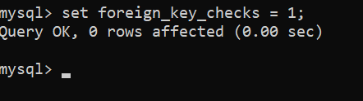

**Q43.** Explain with a query why indexes are automatically created when foreign keys are added.

**Q44.** Create a table employees with CHECK that salary > 20000.

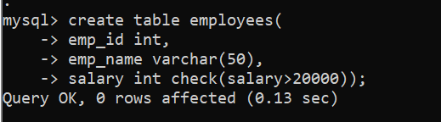

**Q45.** Insert (id=1, salary=15000). What error code will you get?

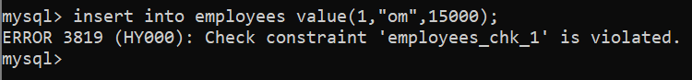

**Q46.** Add a CHECK constraint on gender column so only 'M' or 'F' is allowed.

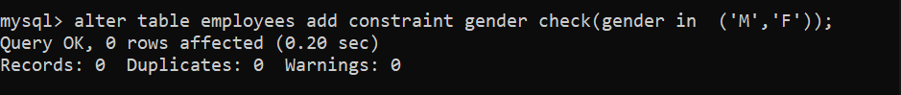

**Q47.** Try inserting gender='X'. What happens?

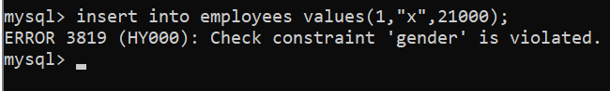

**Q48.** Add a foreign key constraint on employee.dept_id referencing department.dept_id.



**Q49.** Drop a primary key constraint from table library. What query do you use?

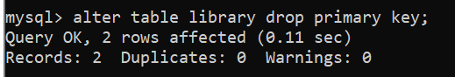

**Q50.** Rename a foreign key constraint fk_emp_dept to fk_employee_department.